close all

clear

clc

%a

dt=0.1e-3;

time_vector=0:dt:4-dt;

%b,c

rate=[20,100,10,50];

% Generate presynaptic spike train as a Poisson process

nSpikes = zeros(size(time_vector));

for i = 1:length(rate)

% Generate Poisson distributed spike counts for each interval

nSpikes((i-1)*round(1/dt)+1:i*round(1/dt)) = (rand(1,round(1/dt))<rate(i)*dt);

end

f1=figure;

plot(time_vector,nSpikes)

xlabel('Time (Sec.)')

ylabel('Spikes')

title('Spikes-Part c');

grid on

saveas(f1, sprintf('Part_c.png'));

%d

dG=1e-9;

G_syn(1)=0;

for i=2:length(time_vector)

G_syn(i)=G_syn(i-1)-dt*G_syn(i-1)/100e-3;

if nSpikes(i)== 1;

G_syn(i)=G_syn(i)+dG;

end

end

f2=figure;

plot(time_vector,G_syn)

xlabel('Time (Sec.)')

ylabel('Conductance Vector')

title('Conductance Vector-Part d');

grid on

saveas(f2, sprintf('Part_d.png'));

%part e&f

p_0=0.5;

D(1)=1;

dG=1e-9;

G_syn_2(1)=0;

for i=2:length(time_vector)

D(i)=D(i-1)+dt*(1-D(i-1))/0.25;

G_syn_2(i)=G_syn_2(i-1)-dt*G_syn_2(i-1)/100e-3;

if nSpikes(i)==1

D(i)=D(i)-p_0*D(i);

G_syn_2(i)=G_syn_2(i)+5e-9*p_0*D(i-1);

end

end

f3=figure;

plot(time_vector,G_syn_2)

xlabel('Time (Sec.)')

ylabel('Conductance Vector')

title('Conductance Vector-Part f');

grid on

saveas(f3, sprintf('Part_f.png'));

%part G

p_0=0.2;

F(1)=1;

D(1)=1;

G_syn_3(1)=0

for i=2:length(time_vector)

F(i)=F(i-1)+dt*(1-F(i-1))/0.25;

D(i)=D(i-1)+dt*(1-D(i-1))/0.25;

G_syn_3(i)=G_syn_3(i-1)-dt*G_syn_3(i-1)/100e-3;

if nSpikes(i)==1

F(i)=F(i)+0.25*((1/p_0)-F(i-1));

D(i)=D(i)-0.2*F(i-1)*D(i-1);

G_syn_3(i)=G_syn_3(i)+4e-9*0.2*F(i-1)*D(i-1);

end

end

f4=figure;

plot(time_vector,G_syn_3)

xlabel('Time (Sec.)')

ylabel('Conductance Vector')

title('Conductance Vector-Part h');

grid on

saveas(f4, sprintf('Part_h.png'));

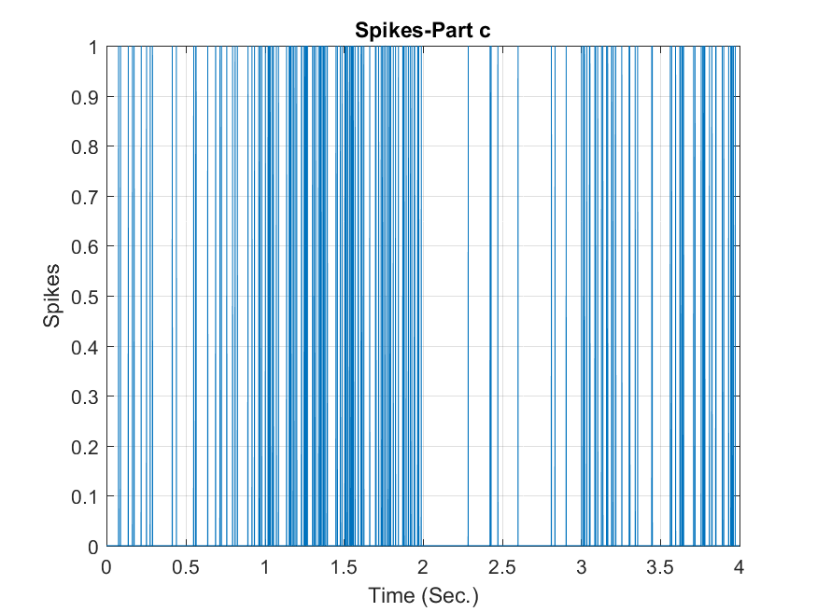

This graph shows the spikes over the time and we can see that the rate of spikes are quite high in interval between 1-2 seconds.

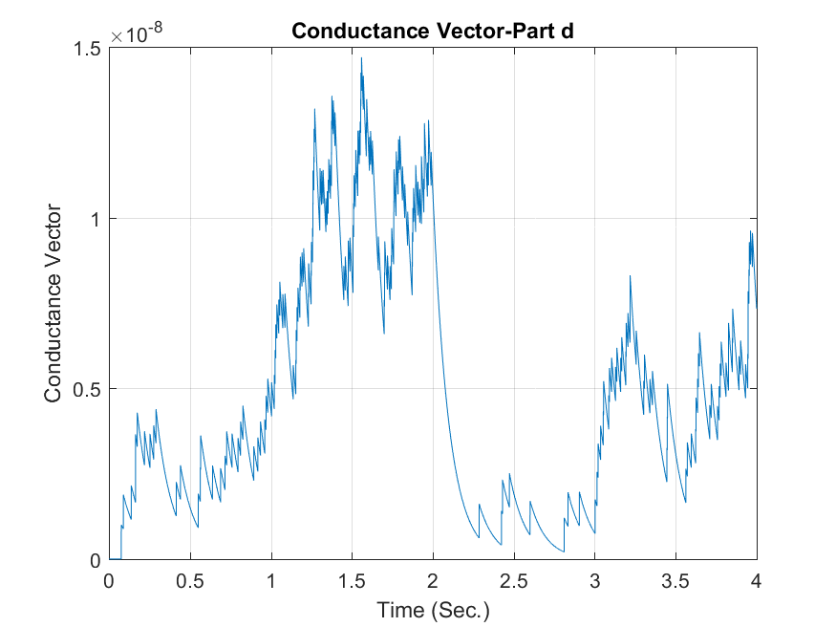

This graph shows the conductance vector over the time. When a spike, or action potential, is produced in a presynaptic neuron, it triggers the release of neurotransmitters into the synaptic cleft. These neurotransmitters then bind to receptors on the postsynaptic neuron, leading to the opening of ion channels and the flow of ions across the membrane. The opening of ion channels is occurring within milliseconds of the arrival of the action potential. As a result, synaptic conductance increases rapidly following the arrival of a spike in the presynaptic neuron. As it can be seen in our figure, whenever neuron transmit a signal, the conductance will increase and then decays. It can be seen that the highest amount of conductance is for interval of 1-2 second which the rate of spikes is very high.

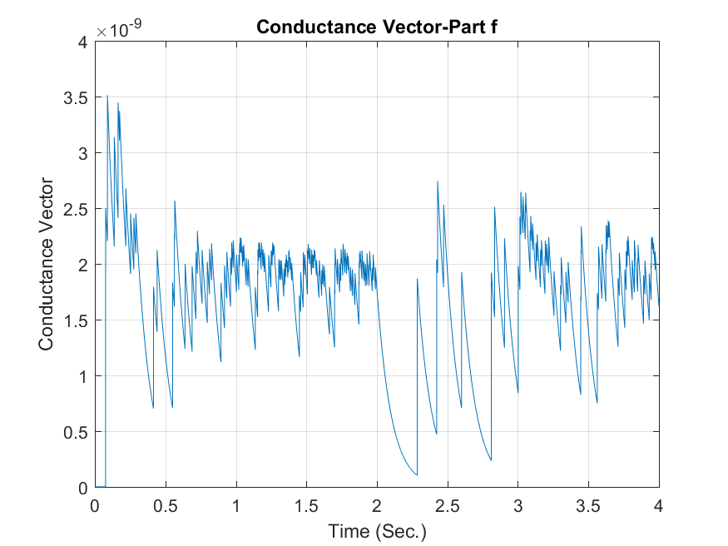

In this figure, we can see depression decrease the strength of synaptic connections. Depression decreases the flow of ions across the membrane in response to neurotransmitter binding and leads to a decrease in synaptic conductance. Also I can see that it better respond to low frequency spikes than higher frequency.

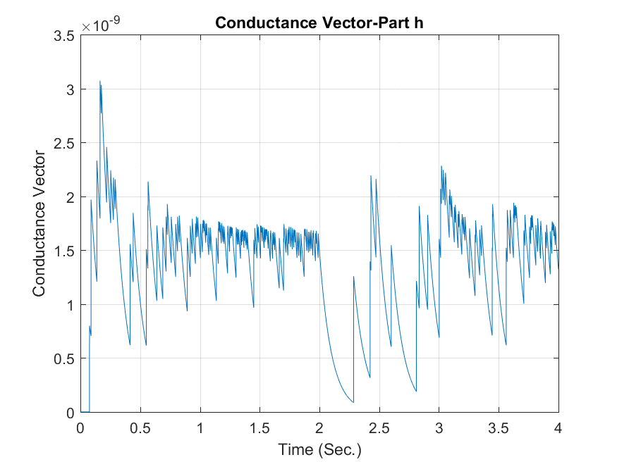

Here I expected that facilitation increase the conductance but it did not. I guess the depression is so strong that it does not let facilitation to act and leads to decrease in conductance.